**10. Perform the following.**

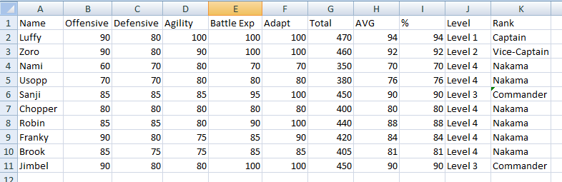

1. **Write a formula to find total of each member.**

Ans. Total = For Luffy: =SUM(B2:F2)

& Brook: =SUM (F10:B10) and so on.

1. **Write a formula to find AVG of each member.**

Ans. Let suppose all the attributes have 100 limits and the total of 5 attributes we get 500.

For Luffy: =AVERAGE(B2:F2) and so on.

1. **Write a formula to find percentage of each member.**

Ans. Percentage: (Total no. /500)*100%

1. **Write a formula to calculate level of each member.**

Ans. =IF(H2>=94,”Level 1”,H2>=94)

=IF(H3>=92,”Level 2”,H3>=92)

=IF(H6>=90,”Level 3”,H6>=90)

=IF(H4>=70,”Level 4”,H4>=90)

1. **Write a formula to find rank of each member.**

Ans. “Captain” for Level 1: =IF(I2>=94,”Captain”)

“Vice-Captain” for Level 2: =IF(I3>=92,”Vice-Captain”)

“Commander” for Level 3: =IF(I6>=90,”Commander”)

“Nakama” for Level 4: =IF(I4>=70,”Nakama”)

1. **Perform conditional formatting on it.**

